Pupil Premium Strategy Statement
Review 2022/2023
Action Steps for 2023/2024

This statement details our school’s use of pupil premium (and recovery premium for the 2022 to 2023 academic year) funding to help improve the attainment of our disadvantaged pupils.

It outlines our pupil premium strategy, how we intend to spend the funding in this academic year and the effect that last year’s spending of pupil premium had within our school.

School overview
Detail | Data
School name | St Stephen’s
Number of pupils in school | 415
Proportion (%) of pupil premium eligible pupils | 4%
Academic year/years that our current pupil premium strategy plan covers (3 year plans are recommended) | 2022/23 to  2024/2025
Date this statement was published | Autumn 2023
Date on which it will be reviewed | Autumn 2024
Statement authorised by | Finance and Premises Committee
Pupil premium lead
Governor / Trustee lead | Alice Bishop
Funding overview
Detail | Amount
Pupil premium funding allocation this academic year | £37,804
Recovery premium funding allocation this academic year | £ TBC
Pupil premium funding carried forward from previous years (enter £0 if not applicable) | £0
Total budget for this academic year  If your school is an academy in a trust that pools this funding, state the amount available to your school this academic year | £37,804

Part A: Pupil premium strategy plan

Statement of intent
At St Stephen’s we build each other up in love and learning, embracing our strengths and developing a passion for lifelong learning. We create opportunities for children to know how to stay safe and see themselves as unique, courageous and resilient global citizens - to be upstanders for fairness and equity and against discrimination and injustice.​
Expectations are high with the view that the children will transfer to their secondary setting with confidence and the prior knowledge needed for continued success. We feel it is important that all members of our community, particularly the disadvantaged, are provided with knowledge and skills to be ready for their next step into secondary school. This strategy outlines how we support both academic, emotional and social needs. We understand that a child’s success requires both areas to be supported.

Our focus is on starting points and identifying what the individual requires to make progress. Action steps follow this process. Progress is reviewed at all ability levels. Our aim is that all disadvantaged and vulnerable children make better than expected progress.

The quality of teaching and learning is a priority as research proves that this is the best way to close the attainment and progress gap between groups of children. Therefore, within the strategy, we will outline how we intend to support continuing professional development.

Our self – evaluation and assessment systems ensure that we are targeting areas that will make the most difference to our disadvantaged children as well as those who are not disadvantaged.

Assessments and pupil progress meetings hone in on the attainment and progress of our children. All staff understand the reason why our work to close the gap is so important.

Children’s social and emotional wellbeing is equally important as this has an impact on learning and success.

Challenges
This details the key challenges to achievement that we have identified among our disadvantaged pupils.
Challenge number | Detail of challenge
1 | 45 % of our PP children require additional support and are on the SEN register or are being monitored because of barriers to learning.
2 | Our work with children and parents provide evidence that we have a high need for wellbeing support for our children on the PP register. Currently, 20% are accessing mentoring
3 | Although our attendance data was lower than average last year, the PP attendance was of particular concern. Out of 19 children, 15 children’s attendance was below the average of 94%. The overall PP average was 89%.
4 | PP children, even with invitations, are not accessing clubs and interventions reducing access to wider opportunities. Funding is required for children to go on trips/additional paid activities and purchase uniform.
5 | Throughout the pandemic and now, the number of PP children making better than expected progress has dropped.

Intended outcomes
This explains the outcomes we are aiming for by the end of our current strategy plan, and how we will measure whether they have been achieved.
Intended outcome | Success criteria
PP children [ including those with SEND]are making better than expected progress | Teachers access coaching.  Teaching is of high quality so that all children, including PP, can access learning  Where required , children will be provided with interventions so gaps are closed and children are making expected progress.  Where children are on the SEND register, there is evidence that all professional recommendations are in place, which are supporting learning. Progress on IPP targets is good and gaps are closing. Children are making expected progress.
To achieve and sustain improved wellbeing for all pupils in our school, particularly our disadvantaged pupils. | Evidence from surveys show that children’s wellbeing has increased. Evidence that the support in place had had an impact on wellbeing
To achieve and sustain improved attendance for all pupils, particularly our disadvantaged pupils. | Sustained high attendance from 2023/24 demonstrated by:  - the overall absence rate for all pupils being no more than 4%, and the attendance gap between disadvantaged pupils and their non-disadvantaged peers being reduced to 0.5%.
Throughout the pandemic and now, the number of PP children making better than expected progress in reading, writing and maths has dropped | By July 2024, evidence from writing, reading and maths moderations, demonstrate that PP children are making at least expected progress.

Activity in this academic year
This details how we intend to spend our pupil premium (and recovery premium funding) this academic year to address the challenges listed above.

Teaching (for example, CPD, recruitment and retention)
Budgeted cost for teaching and learning: £10,000
Activity | Evidence that supports this approach | Challenge number(s) addressed
Staff supported to embed science of learning within everyday practice which impacts on all learning | Research from EEF and other sources provide evidence that when staff understand the science of learning and implement it within their class there is a positive impact on all learners’ progress  https://d2tic4wvo1iusb.cloudfront.net/documents/guidance/Cognitive_science_approaches_in_the_classroom_-_A_review_of_the_evidence.pdf?v=1629124457  https://www.teachertoolkit.co.uk/wp-content/uploads/2018/10/Principles-of-Insruction-Rosenshine.pdf | 1, 4,5
Instructional coaching will be used to support staff to develop their teaching which will impact on all learners | 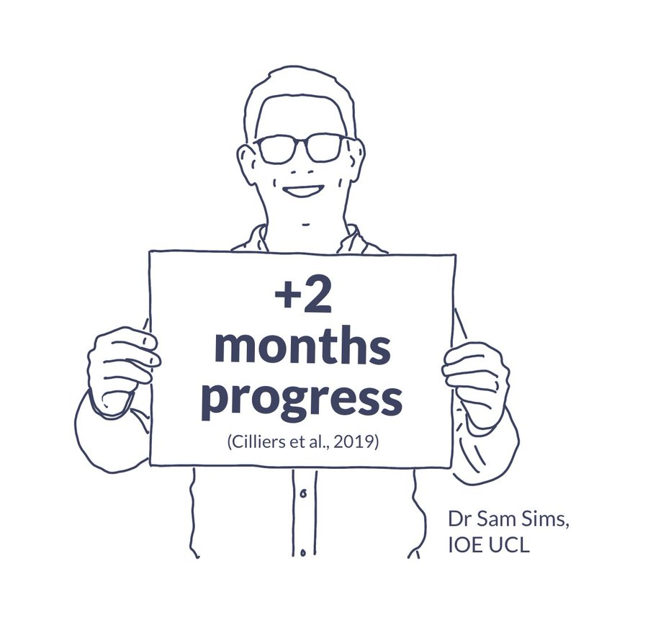 | 1,4, 5
To support staff in using the new spelling programme [ CUSP] | The programme is based upon using cognitive science to teach spelling. | 1,5
Purchase of a DfE validated Systematic Synthetic Phonics programme to secure stronger phonics teaching for all pupils. | Phonics approaches have a strong evidence base that indicates a positive impact on the accuracy of word reading (though not necessarily comprehension), particularly for disadvantaged pupils:  Phonics | Toolkit Strand | Education Endowment Foundation | EEF | 1,5
Continuing to train keystaff on mental health and attachments and social communication. Continuing to embed the interventions for children who may need support with social and emotional challenges. To provide direct support to children through mentors directly supporting emotional wellbeing, self- regulation and behaviour. | There is extensive evidence associating childhood social and emotional skills with improved outcomes at school and in later life (e.g., improved academic performance, attitudes, behaviour and relationships with peers):  EEF_Social_and_Emotional_Learning.pdf(educationendowmentfoundation.org.uk) | 2,3,4,5

Targeted academic support (for example, tutoring, one-to-one support structured interventions)
Budgeted cost for targeted support: £34,044
Activity | Evidence that supports this approach | Challenge number(s) addressed
Additional phonics catch up sessions [ using Little Wandle] targeted at disadvantaged pupils who require further phonics support. | Phonics approaches have a strong evidence base indicating a positive impact on pupils, particularly from disadvantaged backgrounds. Targeted phonics interventions have been shown to be more effective when delivered as regular sessions over a period up to 12 weeks:  Phonics | Toolkit Strand | Education Endowment Foundation | EEF | 1,5
Engaging with the National Tutoring Programme and continue with our in- house teaching support to provide a blend of tuition, mentoring and school-led tutoring for pupils whose education has been most impacted by the pandemic. A significant proportion of the pupils who receive tutoring will be disadvantaged, including those who are high attainers. | Tuition targeted at specific needs and knowledge gaps can be an effective method to support low attaining pupils or those falling behind, both one-to-one:  One to one tuition | EEF (educationendowmentfoundation.org.uk)  And in small groups:  Small group tuition | Toolkit Strand | Education Endowment Foundation | EEF | 1,5
Wider strategies (for example, related to attendance, behaviour, wellbeing)
Budgeted cost for wider strategies:£5,000
Activity | Evidence that supports this approach | Challenge number(s) addressed
https://www.gov.uk/guidance/senior-mental-health-lead-training  Inclusion lead is taking part in Mental Health lead training.The lead and other staff have attended training [ e.g. ELSA] to develop expertise in supporting children’s wellbeing. An audit and action plan has been completed to further improve our provision.  Continued employment of 2 mentors and engagement of a counsellor to support the wellbeing of children, including a high proportion of disadvantaged children. In addition, the school engages a wellbeing service for parents so that the support for the children can be sustainable even when they have left our school. | The mental health training is based upon research based strategies that the school is using to support the children and parents.  Our own evidence from feedback from children and parents | 1,2,3,5
Embedding principles of good practice set out in the DfE’s Improving School Attendance advice.  Training and release time for staff who lead on attendance to embed procedures. | The DfE guidance has been informed by engagement with schools that have significantly reduced levels of absence and persistent absence. | 3,5
To identify PP/ vulnerable children who are not currently attending clubs this year. To work with staff to find a club that would most benefit that individual e.g. music tuition, art based upon interests and strengths. Identify barriers that may prevent this from happening and if possible solve them. Fund the clubs for the PP children. | Children attending a range of activities builds self- confidence and they are developing further skills which may be out of their normal scope. | 4
Contingency fund for acute issues. | Based on our experiences and those of similar schools to ours, we have identified a need to set a small amount of funding aside to respond quickly to needs that have not yet been identified. | All

Total budgeted cost: £44,049

Part B: Review of outcomes in the previous academic year

Pupil premium strategy outcomes
This details the impact that our pupil premium activity had on pupils in the 2022 to 2023 academic year.
Last year
We used catch up funding for PP and other children who required additional support to close gaps. The money was used to run interventions both within and out of class. We completed monitoring of interventions and even when children did not yet meet targets, they made progress towards those goals.
The progress in reading,made by PP children, increased from 79% to 84% . Out of 24 children, 16 made expected progress, 4 made better than expected progress and 4 did not make enough progress. 4 were in Year 6.
The progress in writing dropped from last year from 87% to 79% . 79% of children made at least expected progress. Out of 24 children, 18 made expected progress and 1 made better and 5 did not make enough progress [ 3 in Year 6]
The progress in maths also dropped from 87% to 79%. Out of 24 children, 18 made expected progress, 1 made better than expected and 5 did not make enough progress [ 4 in year 6]
The data has been impacted by poor Year 6 progress. This is the impact of a difficult journey for this cohort through KS2. However, when we look at progress within the year [ from end of year 5 to end of year 6 ] all Year 6 children made progress. This is a result of intense interventions. This data provides evidence that the interventions, including NTP, had a positive impact.
We used the PP premium for academic intervention, support with uniform, trips and wellbeing.
We used the PP premium for academic intervention, support with uniform, trips and wellbeing.
This will continue this year and we will continue to review our interventions to achieve our aim of 100% of our children making at least expected progress. Our priority this year is to ensure that interventions are effective . Phase leaders will meet with teachers every three weeks to consider interventions, the targets set, methodology and impact.

Further information (optional)
Additional activity
Our pupil premium strategy will be supplemented by additional activity that is not being funded by pupil premium or recovery premium. That will include:
- embedding more effective practice around feedback and assessment. We worked with staff on using formative assessment effectively. EEF evidence demonstrates this has significant benefits for pupils, particularly disadvantaged pupils.
- offering a wide range of high-quality broad curriculum activities to boost wellbeing, self- esteem and aspiration. The school is proud of the provision which includes areas that would only be accessed through clubs/ paid tutors in other settings e.g. music, sports’ coach.
Planning, implementation, and evaluation
We used the EEF’s implementation guidance to help us develop our strategy, particularly the ‘explore’ phase to help us diagnose specific pupil needs and work out which activities and approaches are likely to work in our school. We will continue to use it through the implementation of activities.

